Get to Know: Studios

Studios Inter-Op Training for ATDs

**Table of Contents**

Supporting Information 3

Introduction 3

Topics Covered 3

Tools Used 3

Base Topology 3

Example Files and Script 5

Repository 5

Tagman Script 6

ATD Environment 7

Creating an ATD 7

Accessing the ATD 8

Sanitizing the ATD 9

Testing a Deployment 9

Using Tags with the Tagman Script 11

Adding Tags 11

Deleting Tags 11

Onboarding Devices 12

Importing Studios and Inputs 13

Enable Import of Inputs 13

Import a Studio 13

Import Studio Inputs 14

Configuring and Submitting Studios 15

Creating Workspaces 15

Assigning Tags 16

Submitting Workspaces 17

Approving and Executing Change Control Operations 19

Examples 21

Example One: Campus Network to ISP 22

Example Two: Campus to Campus EVPN 26

Example Three: Campus iBGP Underlay 30

Example Four: BGP DC Interconnect 34

Example Five: OSPF on DC Border Leaf 37

Example Six: DC Border Leaf OSPF per VRF 40

Example Seven: eBGP Routed Enterprise 43

Example Eight: Campus Switch Stacking 46

Example Nine: EVPN eTree IPv6 Underlay 50

# Supporting Information

This section contains information to support you in completing the examples. It provides an explanation of the tools used and the necessary workflows you will complete.

The examples reference the information given here, so you can complete the examples without reading through the supporting information.

## Introduction

This document contains several use case examples for understanding how to leverage Studios to meet current customer needs. Each example uses multiple studios to deploy complex networks, and the configuration for each deployment is provided. Once deployed, the example networks can be tested to demonstrate functionality.

## Topics Covered

1. Loading and deleting tags through the API
2. Working with Studios github repository
3. Importing custom Studios, cloning Studios
4. Turning on Alpha features
5. Import and export of inputs files
6. Combining Roles on devices to inter-connect them
7. Editing Studios UI schema
8. eBGP and policy
9. Protocol redistribution
10. Building EVPNs over DCs and a routed Campus
11. Configuring virtual switch stacks
12. OSPFv3 and IPv6
13. Editing Studios templates
14. Getting the latest built-in Studios from the CloudVision repo

### Tools Used

The examples and their configuration are provided through GitHub. You will be able to import each studios configuration and upload tags using a script, tagman.py, provided in the repository. This means that minimal time will be required to configure the studios.

You’ll use an Arista Advanced Routing ATD for these examples, which provides a CloudVision environment.

### Base Topology

Each example uses devices from the below topology, which you should familiarise yourself with:



Each example has its own topology based on this, and which is provided in the instructions for the examples.

## Example Files and Script

The examples are contained in a GitHub repository and contain all of the configuration and the supporting script to successfully complete each example.

### Repository

The repository is accessible here:

<https://github.com/arista-netdevops-community/CloudVisionPortal-Examples>

The examples are contained in the following path:

CloudVisionPortal-Examples/CloudVision_Studios/InterOp_Examples_for_Studios/

The Studio versions to be used are in the CloudVisionPortal-Examples/CloudVision_Studios/InterOp_Examples_for_Studios/

/Studios_to_Use directory.

Tags Files to import are in the CloudVisionPortal-Examples/CloudVision_Studios/InterOp_Examples_for_Studios/

/Tags_Files directory.

Each Ex. X Example directory contains the inputs for each studio used in that example.



### Tagman Script

The tagman.py script, which is used to manage the tags required for each example. You’ll run this script to add or delete the tags for the examples; each example’s folder contains a .txt file, which is composed of that example’s tags.

The tagman.py script is found in CloudVisionPortal-Examples/CloudVision_Studios/InterOp_Examples_for_Studios/

/Tags_Files directory.

## ATD Environment

The ATD (Arista Test Drive) is the environment used to configure and deploy these examples. With it, you’ll be able to import the necessary tags and configuration for each example and sanitize the environment when finished.

The ATD has two states: Running and Shut Down. Typically, an ATD runs for 8 hours and then shuts down. You’ll need to start the ATD once it has shut down, and it can take 10 minutes for CloudVision to restart.

You can sanitize your ATD environment using the tagman.py script found in the repository.

### Creating an ATD

You’ll deploy a new ATD when you want a new environment to configure and deploy these examples inside. It is not necessary to create a new environment for each example; you can sanitize the environment when finished.

1. Visit <https://testdrive.arista.com/>
2. Login

**Note**: You may need to request access to this service if you are unable to login

1. You’ll be brought to the Administration screen, where you should configure a new ATD in the following way:



1. Click **Submit** and the new ATD will be deployed

You’ll receive an email with the access tokens, and can now access this ATD environment

### Accessing the ATD

When an ATD has been created, you’ll receive access tokens to enter the environment and it will start automatically. Typically an ATD will run for 8 hours before shutting down, and if it has shut down you’ll need to restart it. The starting process can take 10 minutes.

1. Access the ATD via its access token
2. You’ll then be brought to the ATD’s management page, where you can start, shut down or access the topology



If the status reads **Your topology is currently: Shut down** click **Start**

1. Click **Click Here to Access Topology** and you’ll be brought to the configuration screen



You may need to scroll down to see all the relevant information.

1. This shows the time remaining on the ATD before it shuts down and needs to be restarted
2. This shows the status of CloudVision. If it does not state “currently UP”, you will need to wait until it does so – CloudVision is still loading
3. These are your login credentials for accessing this ATD’s CloudVision instance
4. Click here to access the instance’s version of CloudVision
5. Click on **CVP** to access CloudVision and login using the lab credentials

### Sanitizing the ATD

You’ll sanitize and ATD using the Tagman script to remove the tags applied for the example, and you’ll also remove any Device Selections made during the studio.

1. Run the tagman script with the delete command
2. Delete the top-level inputs in each configured studio



1. Confirm that the tags have been deleted. Enter Tags and check the box “Select All” 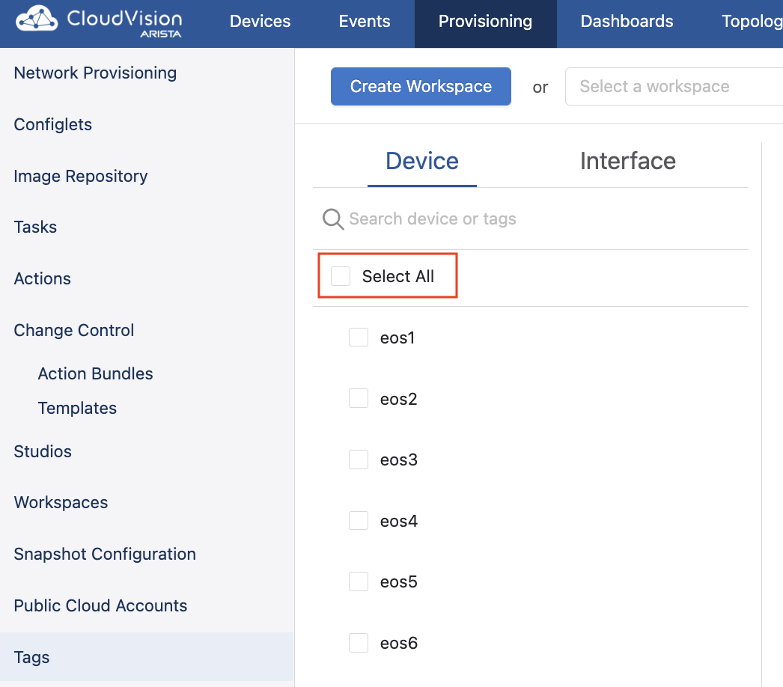
2. Confirm “No tags assigned” is indicated. 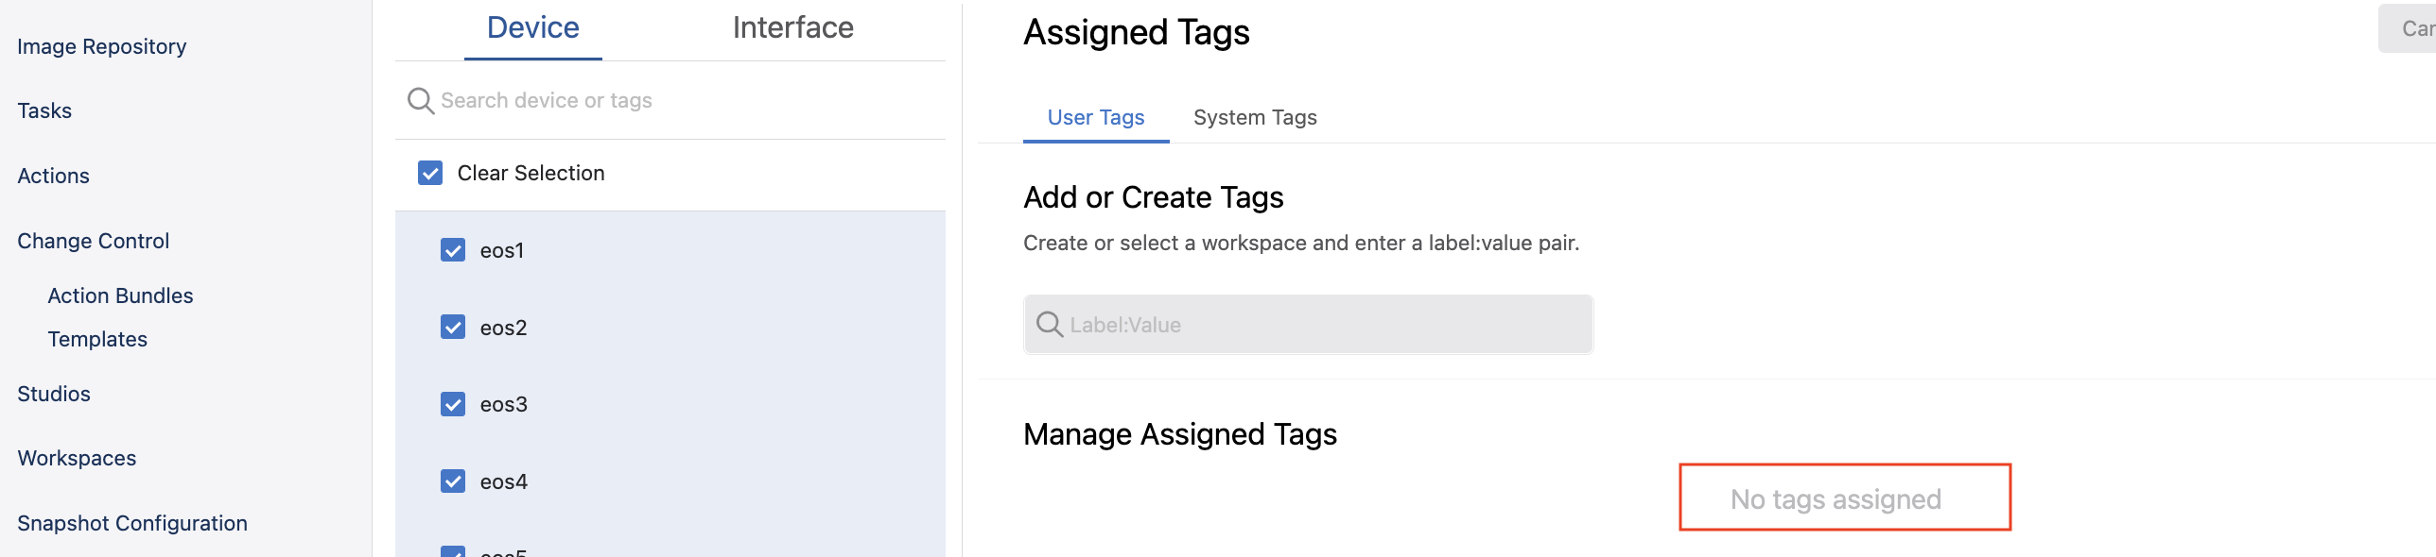
3. Device selection box can remain set to All Devices 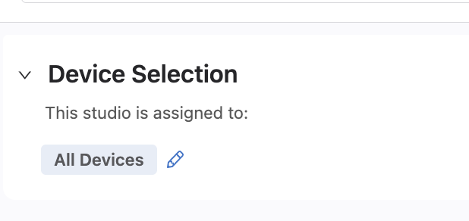

The ATD is now sanitised and you can begin importing tags for a new example, and configuring the studios required for that example.

### Testing a Deployment

On the configuration screen, you will be able to access a CLI for each device in the topology.

Click on a device in the topology to access its CLI. Use the lab credentials of your ATD to log into the device’s CLI.



## Using Tags with the Tagman Script

A python script, tagman.py, is provided with the repository. This can be used to add and delete the required tags for each example quickly.

A specific file, tagsfile.txt, is provided with each example that can be exported to the ATD using tagman.py.

The syntax of the command to run the script is:

|  |
| --- |
| $ python tagman.py -u [ATD username] -p [ATD password] -c [ATD DNS without preceding “https://” and trailing “/”] -f [the example tagsfile.text] -a import |

**Note**: Any open workspace in the ATD will be unaware of any changes to tags you make with tagman.py. You will need to create a new workspace after running any of its commands.

You can check the status of the tags on the ATD in the Tags section of Provisioning.

### Adding Tags

To add tags for a given example, you’ll append -o add to the command, like in the example below that adds Example 1 tags:

|  |
| --- |
| $ python tagman.py -u arista -p arista4f2k -c unf-1-d2c4af25.topo.testdrive.arista.com -f tagsfile-example1.txt -a import -o add |

### Deleting Tags

To delete tags, you’ll append -o delete to the command, like in the below example that deletes the Example 1 tags:

|  |
| --- |
| $ python tagman.py -u arista -p arista4f2k -c unf-1-d2c4af25.topo.testdrive.arista.com -f tagsfile-example1.txt -a import -o delete |

## Onboarding Devices

Devices need to be onboarded to the Studios environment in order for configuration to be pushed to them. If you do not onboard the devices, any configuration created and subsequently executed in Change Control will not be applied to the devices.

1. Create a Workspace and enter Inventory and Topology
2. Click the **Updates** tab and click **Add All New Updates**



1. Click **Review Workspace**
2. Submit the workspace

The devices are now available to be provisioned by Studios and configuration can be pushed to them.

## Importing Studios and Inputs

The studios and inputs required to complete the examples are available for import in the CloudVision_Studios folder of the cloned repository.

### Enable Import of Inputs

1. Visit General Settings in Settings
2. Press ctrl + A to reveal the alpha settings



1. Scroll to the bottom of Features and enable Studios Alpha Features



You’ll now be able to import Studio inputs.

### Import a Studio

1. Visit Studios
2. Create a workspace
3. Click **Import**



1. In the Import mode, navigate to the Studios_to_Use directory in the repository.
2. Select each studio and import them all. Which specific studio to use is specified within each example.
3. Click **Upload**
4. Make a clone of the L3LS Studio. We will use this clone in the course so we can make modifications to it later.

The Studios will now be available to configure.

### Import Studio Inputs

1. You need to access the studio that you want to import the inputs into
2. Within the studio, click the **ellipsis** beside Edit



1. Select **Import** under Inputs and navigate to the inputs file in your folder
2. Click **Upload**

Once you have done this, the studios will include the configuration.

## Configuring and Submitting Studios

The vast majority of the configuration required to successfully deploy these examples is imported. You will, however, need to do some basic configuration and complete the essential workflows of Studios.

More information on using Studios can be found [here](https://docs.google.com/document/d/1Hsib-Ox-ycp1iTPiuzKY7Om8ve7Ej_d1FOWeAWhAju4/edit).

### Creating Workspaces

A workspace is an instance used to record and build configuration changes you make in Studios. You’ll need to create a workspace to import studios and inputs, to onboard devices, and to configure studios. You can complete these examples with one workspace or you can use multiple workspaces.

1. Click **Create Workspace**, which will bring up the Create New Workspacemodal. You can do this within Studios:



1. Give your new workspace a name and a description, and then click **Create**



The Workplace you’ve created can now be used to manage the configuration of one or more studios. It will be available for use in the workspace dropdown menu.

### Assigning Tags

Tags identify the devices a studio will configure and are used in inputs. You’ll need to assign tags to any studios that you configure so that configuration can be pushed to those devices.

Within each studio, with the exception of Inventory and Topology, there is a Device Selection option.



You’ll use Device Selection to specify the devices that any given studio’s configuration affects. All of the tagged devices you select must already have been onboarded for use in Studios with the [Inventory and Topology Studio](https://docs.google.com/document/d/1Hsib-Ox-ycp1iTPiuzKY7Om8ve7Ej_d1FOWeAWhAju4/edit#heading=h.9swfxqanlo73). In order to assign devices, click **Set Tag Query** and then enter a device tag query.



You can edit these tagged devices at any point with a workspace by clicking the pencil icon to the right of the last tag.

You can use tags to apply an entire studio to a selected group of devices. For example, you may want the configuration of a studio to relate only to devices in a particular data center. All devices in that data center can be tagged under a label, and you can assign that studio to that tag label.

When adding multiple items with the same label (the part of the tag to the left of the colon) use a Comma “,” on your keyboard to open a new drop-down list and click the next device. When adding items that have different labels, type “or” in the Device Selection Box and then select “OR” from the drop-down list. Notice the commas and OR in the example below.



### Submitting Workspaces

You’ll submit workspaces to Change Control in order to push a workspace’s configuration to devices. The workspace’s configuration is then approved and executed in Change Control.

1. Click the **Review Workspace** button in the header



1. The workspace will be automatically built for submission, which includes input validation, compiling the configuration, and the validation of the configuration. On the Build screen, you’ll be able to [review the proposed configuration changes](https://docs.google.com/document/d/1Hsib-Ox-ycp1iTPiuzKY7Om8ve7Ej_d1FOWeAWhAju4/edit#heading=h.1x0gk37)

**Note**:The workspace is automatically built only for the first time that you click ReviewWorkspace. Any subsequent changes made after that will require that you re-build the workspace by clicking **Start Build**.

1. Once satisfied, you can click **Submit Workspace**



1. You’ll be presented with a modal that will bring you to Change Control



A change control operation will now be created and you can approve and execute this in Change Control.

**Note**:Not all workspace submissions will create a change control operation. The View Change Control button will be disabled when no configuration changes have been created, but any other changes will come into effect.

### Approving and Executing Change Control Operations

Once a workspaces has been submitted, it creates a change control operation that must be approved and executed. When executed, the configuration submitted by the workspace is pushed to the devices.

1. Click **Review and Approve**



1. You’ll now see a modal that displays a summary of the configuration changes, which also allows you to add a custom note to the change control



1. Toggle on **Execute Immediately** and click **Approve and Execute**

The change control operation will now begin to execute and its configuration will be pushed to devices.

# **Examples**

Ten examples are provided showing diverse network deployments using multiple studios. These examples can be completed quickly and effectively, enabling you to understand how studios functions on a basic level and how it meets today’s networking demands.

The supporting information given above is referenced within the examples, and it is not necessary to begin with any specific example.

**Note**: You must set up an ATD in order to run and deploy these examples.

## Example One: Campus Network to ISP

**Overview**

In this example, you’ll deploy a campus network that is connected to an ISP. Between the Campus and the ISP is an Edge Router (ER) acting as a network core/WAN router that runs OSPF to the Campus Splines and eBGP to the ISP. The BGP policy on the WAN router sends an Aggregate route to the ISP and sends only a default route to the Campus. Be sure to have read through the prep section above and have completed any tasks there.

Please look over the diagrams to get a feel for what we are about to configure.



**Topology**



**Features**

* MLAG and virtual router address
* Routed interface and eBGP to external peer
* OSPF on Campus Splines
* OSPF to BGP redistribution
* Prefix list and BGP policy towards ISP
* OSPF default information originate

**Import**

Enterprise Routing

Campus Fabric

After importing these enter each Studio, click edit in the upper right, and rename both Studios to something custom – perhaps you customer name.

**Configure**

1. Sanitize the ATD, if necessary
2. Run the tagman.py script for tagsfile-example1.txt
3. Import the Enterprise Routing and Campus Fabric studios inputs
4. Device Selection “All Devices” for each studio

**Deploy**

You’ll now push the configuration you’ve imported to the devices:

1. Review and submit the workspace to Change Control
2. Approve and Execute the change control operation

**Review**

Please review the configurations on the devices in the lab to be sure they are configured as you would expect. vlan15 is a management vlan in the Campus Studio. By indicating the vlan “management” makes it the native vlan and leaf switches get a management IP address and default route.

On Campus Splines OSPF is configured by using the Enterprise Routing Studio. Notice the routing table of eos11 and eos13 there are routes for ISP addresses 10.10.10.10 and 19.19.19.19.

**Test**

Use the ATD’s configuration screen to access a CLI for the below devices:

* From eos12 ping eos10 10.10.10.10 and eos19 19.19.19.19

**Task**

#1 Goal – Source a default route from eos1 block the specific routes coming from the ISP.

* In the Enterprise Routing Studio find the Core Router eos1 and enter the page for the BGP Peer Group.
* Enable OSPF Default Information Originate “Always Send” and add a deny filter in the redistribute route map that prevents the Internet routing detail from entering the Campus. 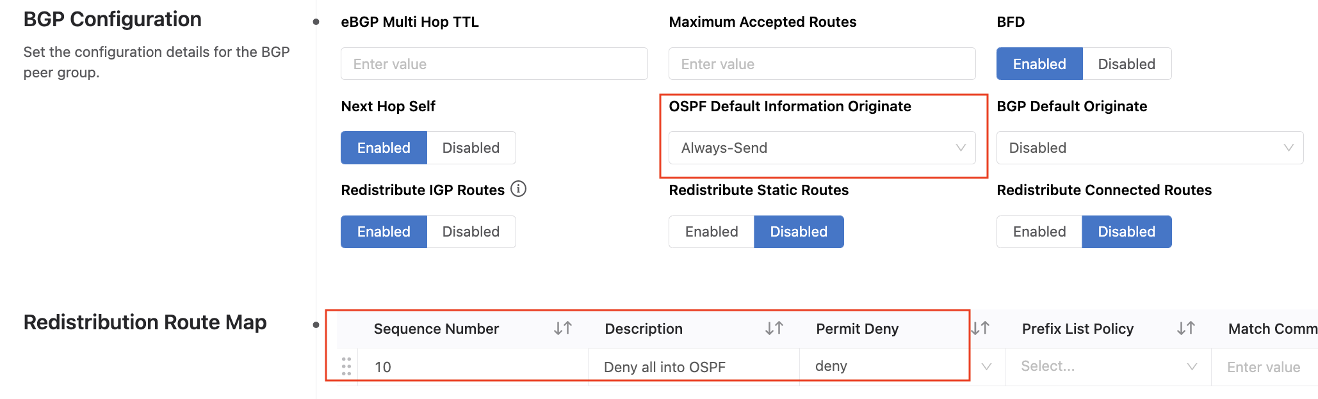

**Test**

Use the ATD’s configuration screen to access a CLI for the below devices:

* From eos12 ping eos10 10.10.10.10 and eos19 19.19.19.19
* Verify that eos11 and eos13 have a default route and no longer have 10.10.10.10 and 19.19.19.19 in the routing table.

**Extra task**

#1 Goal – Learning hiding and Showing UI fields in a Studio.

* Go to the Enterprise Routing Studio and the ISP Network .
* Notice there is a OSPF specific MAX LSA field at the bottom of the page even tough ISIS is being used by the ISP. So this setting does not apply to ISIS.
* Edit this Studio to hide OSPF MAX LSA field and only show it when OSPF is selected.

#2 Goal - Add a Port Mirror session to eos7. We will use the Campus Interfaces Studio for this task.

* Add a Site and select tag device:eos7 
* Add a Switch-Group tag to eos7 called Switch-Group: eos7 
* Click the arrow and at the top of the next page add eos7 to the Assigned Devices box.
* 
* Add at the bottom of the page configure your Port Mirror session and build the workspace
* Yikes! cEOS does not support port mirroring feature.

**Note:** Some features are not available on the veos-lab or cEOS image we are using in the ATD.

**Also Note:** tagman.py will not clean-up the “Switch-Group” tag we added in the Extra Task. You can delete this tag manually to complete the clean-up.

## Example Two: Campus to Campus EVPN

**Overview**

In this example, you’ll deploy a second Campus and stretch a vlan between the Campus using EVPN and VXLAN. The internal routing protocol is ISIS and the EVPN control is using iBGP and a separate Route Reflector (perhaps this is a VM in the real world). Both users are on the same vlan and the user on the left should be able to ping the user on the right. The ISP should still be reachable.

Please look over the diagrams to get a feel for what we are about to configure.



**Topology**



**Features**

* EVPN control plane
* MAC VRF on Campus Splines
* Trunk port and Routed port profiles

**Import**

Enterprise Routing

Campus Fabric

EVPN Services

Campus Interfaces

**Configure**

1. Sanitize the ATD, if necessary.
2. Run the tagman.py script for tagsfile-example2.txt
3. Import the Enterprise Routing, EVPN Services, Campus Interfaces, and Campus Fabric inputs
4. Set the Device Selection to “All Devices” for each studio

**Deploy**

You’ll now push the configuration you’ve imported to the devices:

1. Review and submit the workspace to Change Control
2. Approve and Execute the change control operation

**Review**

Please review the configurations on the devices in the lab to be sure they are configured as you would expect. Look at the Campus Splines and see that to add ISIS use the Enterprise Routing Studio. Look at the BGP policy on eos1 that only allows the default route sent by the ISP to be redistributed into ISIS.

**Test**

Use the ATD’s configuration screen to access a CLI for the below devices:

* From Campus switch eos12 ping DC end device eos9 15.15.15.133 and eos20 15.15.15.134
* From Campus switches eos12, ping to eos10 10.10.10.10 and eos19 19.19.19.19 on the ISP Network to be sure the ISP connection is still working.
* From Campus end devices eos9 and eos20, ping from vrf vlan15 to eos10 10.10.10.10 and eos19 19.19.19.19 on the ISP Network

**Task**

#1 Goal - Add vlan 16 to Campus-eos2-eos3-eos4-eos5 and change the edge ports to be trunk ports

* In the Campus Fabric Studio give a VIP of 16.16.16.128, eos2 IP address of 16.16.16.129/24, and eos5 IP address of 16.16.16.130/24
* In the Campus Interfaces Studio add the “TRUNK” profile to the exiting port configurations on eos3 and eos4. The TRUNK profile is pre-configured so all you need to do it apply it to the ports.
* The end devices have been pre-configured with IP address 16.16.16.133 in vrf vlan16 for eos9 and 16.16.16.134 in vrf vlan16 for eos20. Use these to test

**Test**

Use the ATD’s configuration screen to access a CLI for the below devices:

* From Campus end devices eos9 and eos20, ping from vrf vlan16 to your default gw 16.16.16.128
* From Campus end devices eos9 and eos20, ping from vrf vlan16 to eos10 10.10.10.10 and eos19 19.19.19.19 on the ISP Network
* From Campus end devices eos9 and eos20, ping from vrf vlan16 to eos12 15.15.15.4

## Example Three: Campus iBGP Underlay

**Overview**

In this example, you’ll deploy the underlay and overlay using iBGP and the Route Reflector is collapsed into the Core Router for both the underlay and the overlay. A vlan is stretched between 2 Campus and the user on the left should be able to ping the user on the right. The ISP should still be reachable.

Please look over the diagrams to get a feel for what we are about to configure.



**Topology**



**Features**

* Pure BGP routed Campus
* Route Reflector and Core router same device

**Import**

Campus Fabric

Enterprise Routing

EVPN Services

Campus Interfaces

**Configure**

1. Sanitize the ATD, if necessary
2. Run the tagman.py script for tagsfile-example3.txt
3. Import the Enterprise Routing, EVPN Services, Campus Interfaces and Campus Fabric inputs
4. Set the Device Selection to “All Devices” for each studio

**Deploy**

You’ll now push the configuration you’ve imported to the devices:

1. Review and submit the workspace to Change Control
2. Approve and Execute the change control operation

**Review**

Please review the configurations on the devices in the lab to be sure they are configured as you would expect.

**Test**

Use the ATD’s configuration screen to access a CLI for the below devices:

* From Campus switch eos12 ping DC end devices eos9 15.15.15.133 and eos20 15.15.15.134
* From Campus switches eos12, ping to eos10 10.10.10.10 and eos19 19.19.19.19 on the ISP Network
* From Campus end devices eos9 and eos20, ping to eos10 10.10.10.10 and eos19 19.19.19.19 on the ISP Network

**Task**

#1 Goal - Add vlan16 with EVPN Studio to stretch it between Campuses

* In Campus Studio add vlan16 to Campus-eos11-eos12-eos13. Make vlan16 the management vlan and not vlan15.
* Do not add a name for vlan16.
* Virtual router IP address 16.16.16.1 and eos11 is address 16.16.16.2/24 and eos13 16.16.16.3/24.
* Change the management IP address for eos12 to be 16.16.16.4/24
* In the EVPN Studio add vlan16 to Tenant pink with the same vteps as vlan15.
* Rebuild your workspace.

#2 Goal – Edit Campus Studio to allow no vlan name.

* Building will fail device validation due to incomplete vlan name. Edit the template in Campus Fabric Studio so vlan name is not mandatory.
* Modify template in Campus Fabric, save your changes, and re-build.

**Review**

Please review the configurations on the devices in the lab to be sure they are configured as you would expect.

**Test**

* From Campus switch eos12 ping DC end devices eos9 16.16.16.133 and eos20 16.16.16.134

## Example Four: BGP DC Interconnect

**Overview**

In this example, you’ll deploy 2 Data Centers and use L3 EVPN in each. The DC Border Leafs have eBGP sessions to the Edge Router in CoreNet and routes learned from the DCs are redistributed into OSPF. There is no EVPN in CoreNet. eBGP on the DC Border Leafs is configured with Enterprise Routing Studio. You will complete the configuration of the Red L3EVPN and eBGP session and test traffic. Servers in the respective DCs should be able to ping each other.

Please look over the diagrams to get a feel for what we are about to configure.



**Topology**

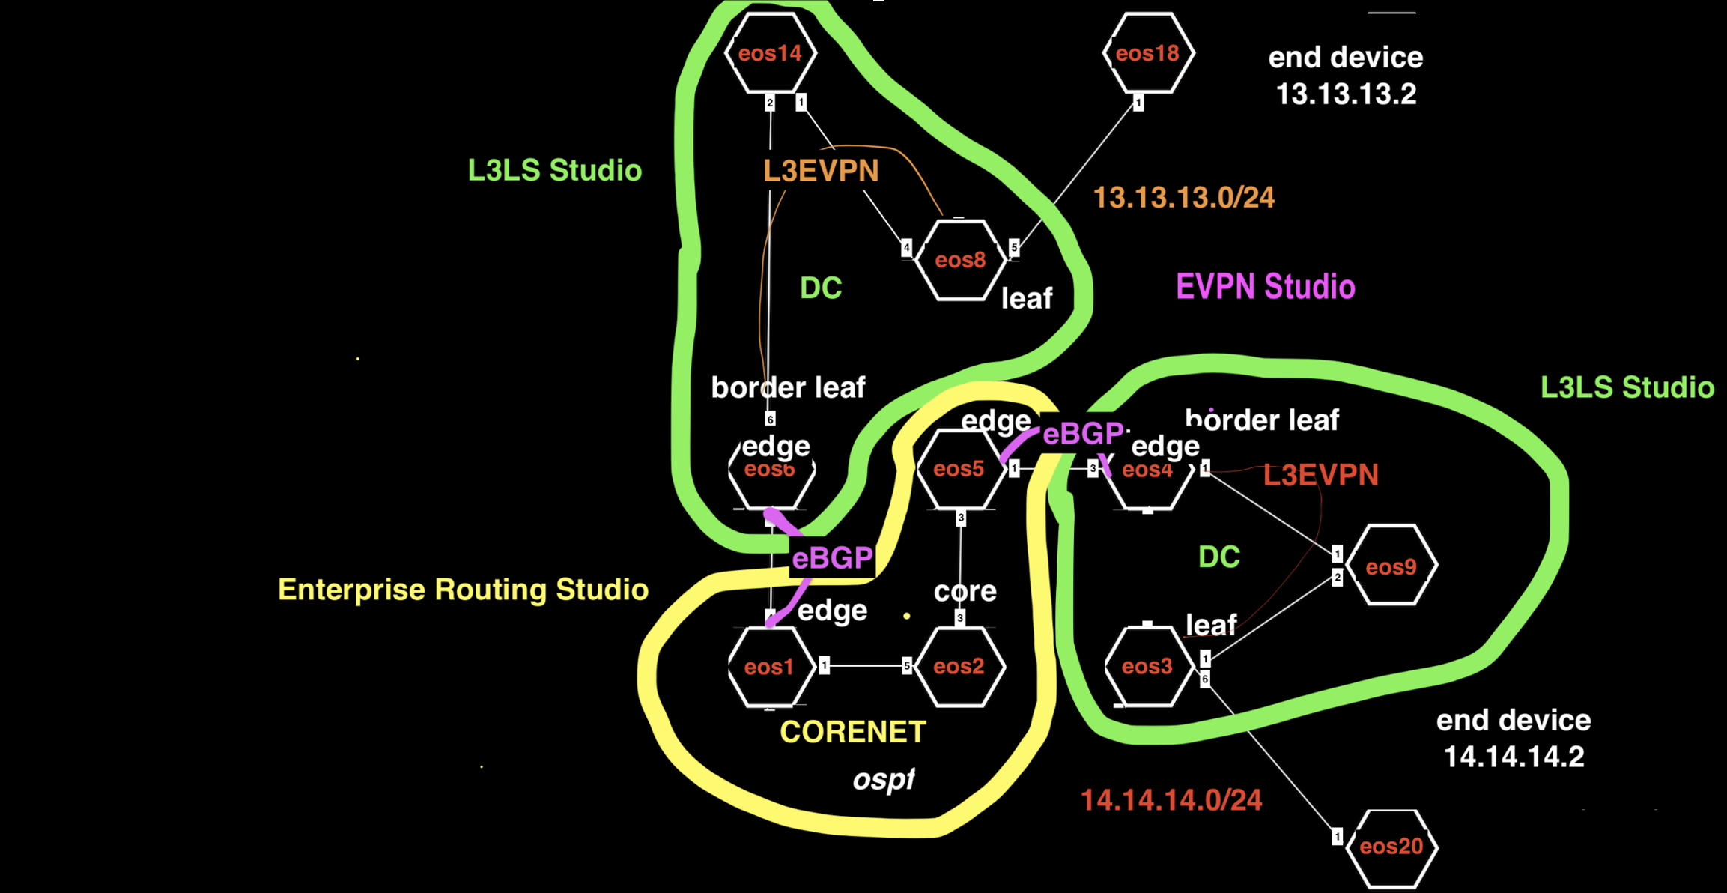

**Features**

* L3EVPN DCs
* eBGP from Border Leaf VRF to Edge Router
* Routed sub-interfaces

**Import**

L3 Leaf-Spine Fabric

Enterprise Routing

EVPN Services

Campus Interfaces

**Configure**

1. Sanitize the ATD, if necessary
2. Run the tagman.py script for tagsfile-example4.txt
3. Import the Enterprise Routing, EVPN Services, Campus Interfaces, and L3 Leaf-Spine inputs
4. Set the Device Selection to “All Devices” for each studio

**Deploy**

You’ll now push the configuration you’ve imported to the devices:

1. Review and submit the workspace to Change Control
2. Approve and Execute the change control operation

**Review**

Please review the configurations on the devices in the lab to be sure they are configured as you would expect.

**Task**

#1 Goal - Complete the configuration of the Red EVPN and eBGP session

* Create new Tenant red with L3 VRF red
* Configure vlan 14 with vtep eos3 and vrf red and IP address 14.14.14.1/24
* Configure vlan 114 with vtep eos4 and vrf red
* To eos4 add L3 interface ethernet3.114 and IP address 114.114.114.0/31
* Configure BGP neighbor 114.114.114.1 ASN 7
* Check that you can ping across the interface and BGP session is established
* Configure eos3 ethernet 6 to be a Trunk port in the Campus Interfaces Studio

**Test**

Use the ATD’s configuration screen to access a CLI for the below devices:

* From eos18 vrf orange ping eos20 14.14.14.2

## Example Five: OSPF on DC Border Leaf

**Overview**

In this example, you’ll deploy a NOC (which is provisioned with the Campus Studio) with redundant routed connections to the L3 DC underlay. The NOC is running OSPF on the Splines to 2 Core Routers and so are the DC Border Routers. We will be redistributing the management subnet for NOC servers into the DC and loopback2 of Leaf switches into OSPF and testing traffic. Because we are mutually redistributing routes in 2 places routing loop will occur. Part of our task is to use BGP policy to stop the loop. The NOC server on the left should be able to ping the switches on the right.

Please look over the diagrams to get a feel for what we are about to configure.



**Topology**



**Features**

* Redundant OSPF to BGP redistribution
* Routing loop prevention with L3LS changing default distance of BGP so BGP preferred over OSPF
* Modifying BGP policy in Enterprise Routing Studio
* Adding additional loopback interfaces with Campus Interfaces Studio

**Import**

Enterprise Routing

Campus Fabric

L3 Leaf-Spine

Campus Interfaces

**Configure**

1. Sanitize the ATD, if necessary
2. Run the tagman.py script for tagsfile-example5.txt
3. Import the Enterprise Routing, Campus Fabric, Campus Interfaces and L3 Leaf-Spine inputs
4. Set the Device Selection to “All Devices” for each studio

**Deploy**

You’ll now push the configuration you’ve imported to the devices:

1. Review and submit the workspace to Change Control
2. Approve and Execute the change control operation

**Review**

Please review the configurations on the devices in the lab to be sure they are configured as you would expect.

**Test**

Use the ATD’s configuration screen to access a CLI for the below devices:

From Campus switch eos12 ping DC Leaf eos9 14.14.14.2 and ping in the reverse direction on eos9 ping NOC eos12 15.15.15.2. Does the ping fail? This is due to a routing loop.

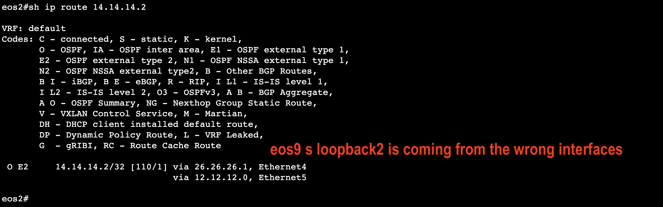

**Task**

#1 Goal – Stop the routing loop:

* In L3LS Studio change the bgp distance of Leaf switches to 10
* Go into the DC Pod configuration and to Leaf BGP Defaults
* Add a command line “distance bgp 10”
* This makes BGP preferred over OSPF

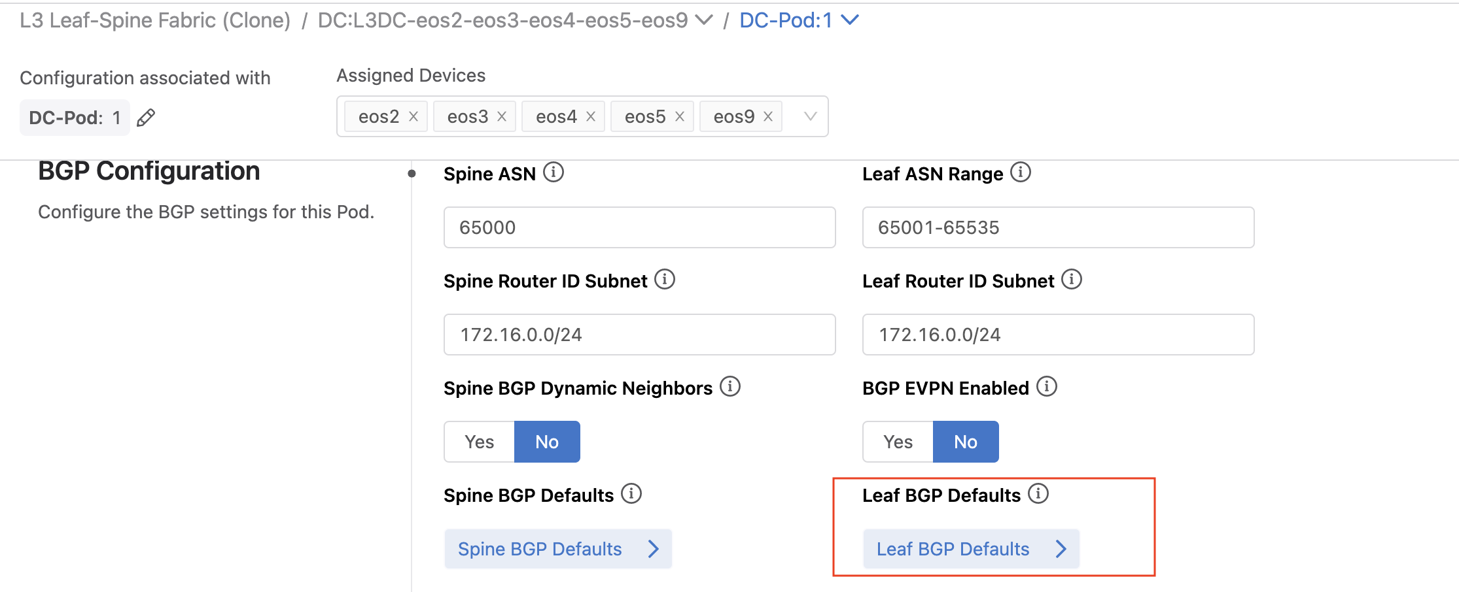

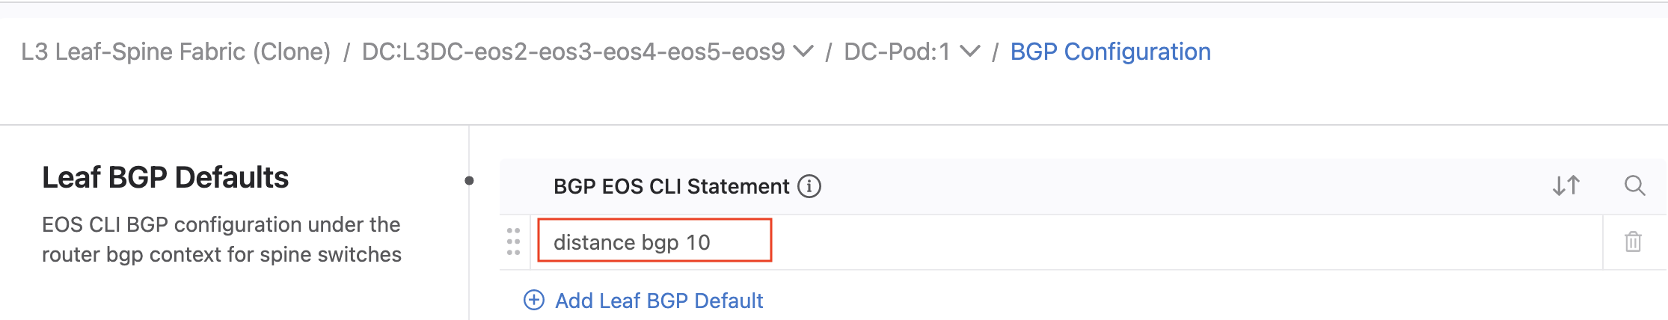

#2 Goal - Add loopback addresses to DC Leaf switches eos3 and eos4:

* In Campus Interfaces Studio add a loopback 2
* 14.14.14.3 to eos3 and 14.14.14.4 to eos4, eos9 loopback2 configuration is already complete.
* Allow the new addresses to be redistributed from BGP into OSPF by adding the new addresses to the prefix list on eos2 and eos5 in the Enterprise Routing Studio. 14.14.14.2/32 has already been configured – follow that example.

**Test**

Use the ATD’s configuration screen to access a CLI for the below devices:

* From Campus switch eos12 ping 14.14.14.2, 14.14.14.3 and 14.14.14.4

## Example Six: DC Border Leaf OSPF per VRF

**Overview**

In this example, you’ll deploy a L2 Data Center and a L3 DC but this time with OSPF in a VRF on the Border Leaf and the DC has a L3 EVPN overlay. The loopback address used for testing in a VRF on eos9. We will be redistributing the loopback address into OSPF and testing traffic. The server on the left should be able to ping the loopback interface on the switch on the right.

Please look over the diagrams to get a feel for what we are about to configure.

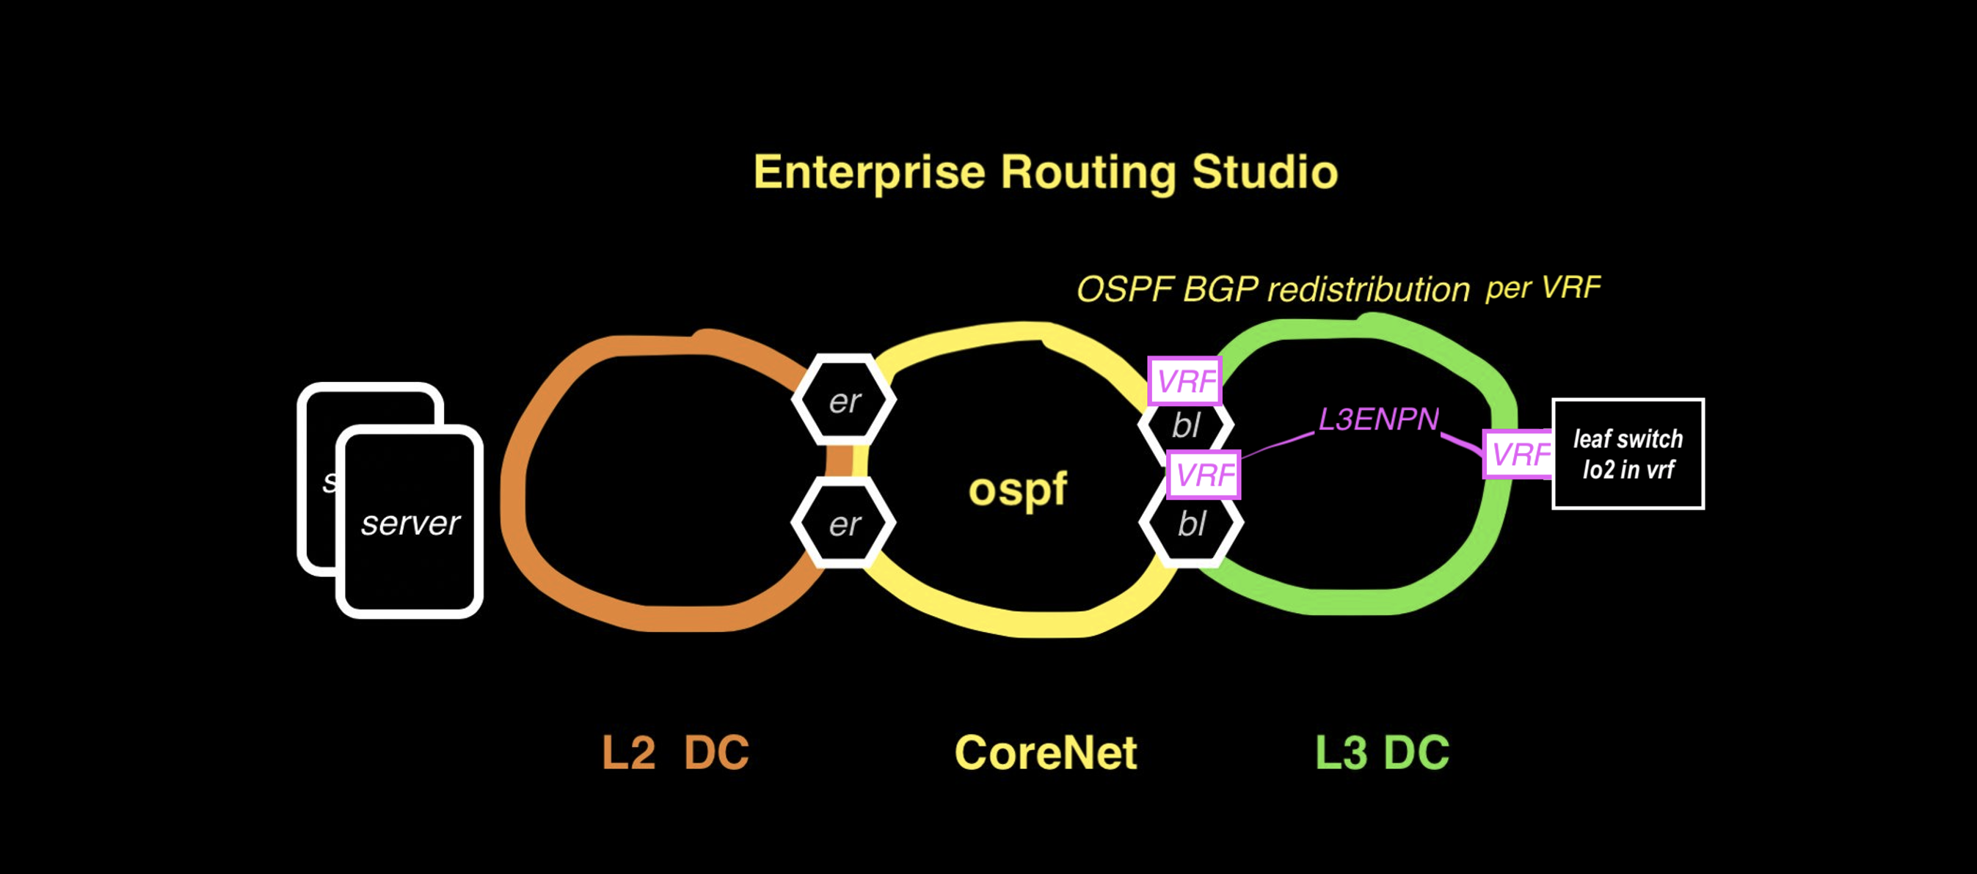

**Topology**



**Features**

* OSPF BGP redistribution in VRF on Border Leaf
* BGP policy with route map
* external sub-interfaces running OSPF - external sub-interfaces in VRFs running OSPF
* Using Campus Interfaces Studio to configure vlans and SVIs in the Campus (instead of the Campus Studio)

**Import**

Enterprise Routing

L3 Leaf-Spine

Campus Fabric

EVPN Services

Campus Interfaces

**Configure**

1. Sanitize the ATD, if necessary
2. Run the tagman.py script for tagsfile-example6.txt
3. Import the Enterprise Routing, Campus Fabric, EVPN Services, Campus Interfaces, and L3 Leaf-Spine inputs
4. Set the Device Selection to “All Devices” for each studio

**Deploy**

You’ll now push the configuration you’ve imported to the devices:

1. Review and submit the workspace to Change Control
2. Approve and Execute the change control operation

**Review**

Please review the configurations on the devices in the lab to be sure they are configured as you would expect.

**Task**

#1 Goal - Add new links on eos2 to Core Router eos6 and configure OSPF

* On eos6 add interface ethernet5.114 26.26.26.1/31 and enable OSPF in the external interfaces section in Enterprise Routing Studio
* On eos1 add interface ethernet1.114 12.12.12.0/31 and enable OSPF in the external interfaces section in Enterprise Routing Studio
* On eos2 add interface ethernet5.114 12.12.12.1/31 and ethernet4.114 26.26.26.0/31 and enable OSPF in vrf “pink” on both interfaces in the external interfaces section in Enterprise Routing Studio
* Be sure there is no routing loop of 14.14.14.2/32

**Test**

Use the ATD’s configuration screen to access a CLI for the below devices:

* From Campus switch eos12 ping DC Leaf eos9 14.14.14.2
* From DC Leaf eos9 14.14.14.2 ping Campus switch eos12 15.15.15.4

## Example Seven: eBGP Routed Enterprise

**Overview**

In this example, you’ll deploy a L2 Data Center (which is provisioned with the Campus Studio) and a L3 DC. There is no OSPF in this example, instead BGP is used in the Core to connect the DCs together. The L2 DC and L3 DC Border Leafs are running eBGP to the Core routers so different ASNs are used for each network. This time instead of using the Campus Studio to configure the vlan and IP addresses you will use the Campus Interfaces Studio. The Enterprise Routing Studio is used to configure the BGP on the Border Leafs due to the complexity of the policy. The server on the left should be able to ping the loopback in a VRF on the switch on the right.

Please look over the diagrams to get a feel for what we are about to configure.



**Topology**



**Features**

* Redundant Border Leaf connections using routed sub-interface
* BGP on Campus Splines
* vlan and SVI configured with Campus Interfaces Studio
* Using ip virtual router with a mask and redistributing into BGP the resultant static route

**Import**

Enterprise Routing

L3 Leaf Spine

EVPN Studio

Campus Fabric

Campus Interfaces

**Configure**

1. Sanitize the ATD, if necessary
2. Run the tagman.py script for tagsfile-example2.txt
3. Import the Enterprise Routing, Campus Fabric, Campus Interfaces, and L3 Leaf-Spine inputs
4. Set the Device Selection to “All Devices” for each studio

**Deploy**

You’ll now push the configuration you’ve imported to the devices:

1. Review and submit the workspace to Change Control
2. Approve and Execute the change control operation

**Review**

Please review the configurations on the devices in the lab to be sure they are configured as you would expect.

**Task**

#1 Goal -Add a new vlan and SVI using the Campus Interfaces Studio

* Follow the example of vlan15 that was previously configured on eos11, eos12, and eos13 in the Campus Interfaces Studio.
* We will be using group member notation for the configurations on eos11 and eos13 (the Splines). Include the member number followed by a slash for the vlan id and choose “group-member-notation” in the Member Number field.
* Use a virtual router address of 16.16.16.1/24 (with a mask) and use dummy IP addresses in the IP Prefix field of 1.2.3.2/31 on both eos11 and eos13
* Add an SVI on eos12 of 16.16.16.4/24 on vlan16 and a default gateway of 16.16.16.1 and in vrf “vlan16”.

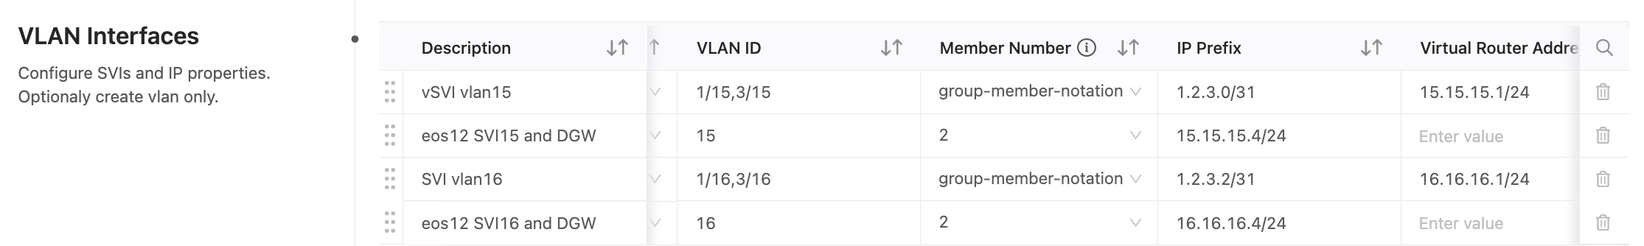

* 16.16.16.0/24 will be in the routing table as a static route.

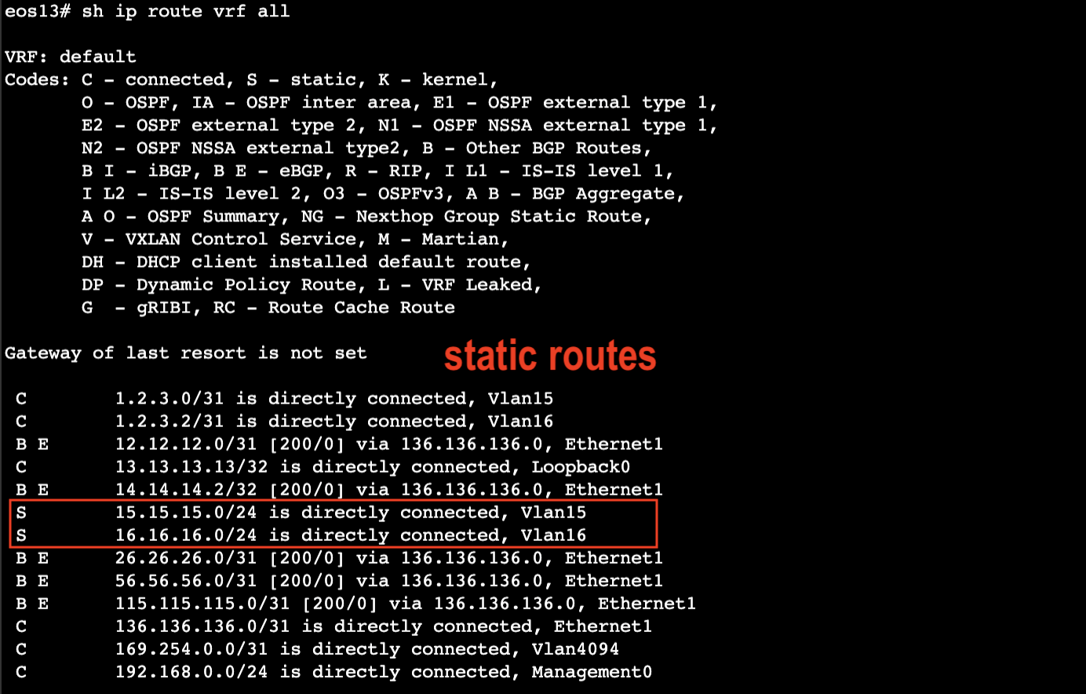

* ****Turn on redistribute static in BGP Peer Groups on eos11 and eos13 in the Enterprise Routing Studio. Do this for peer groups IBGP and EBGP on both switches.

 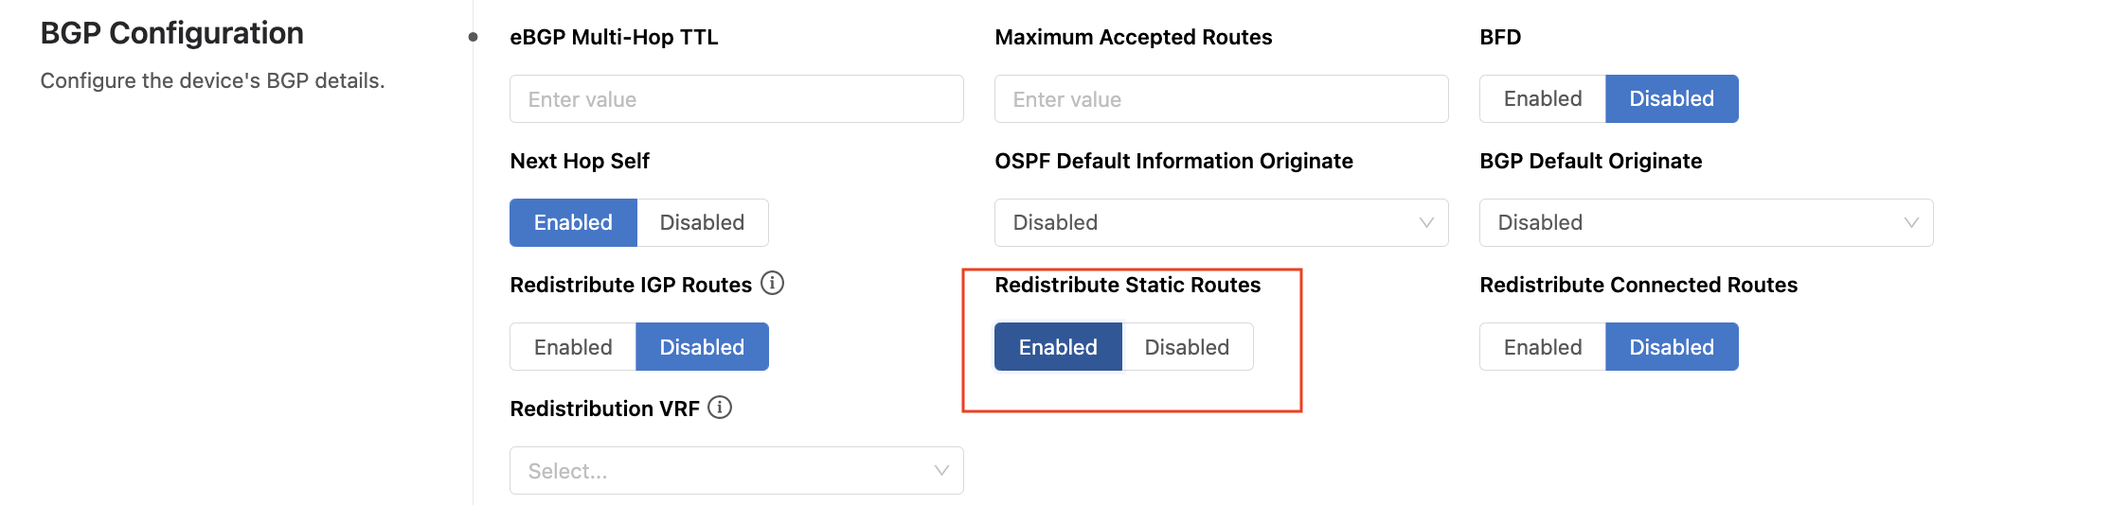

**Test**

Use the ATD’s configuration screen to access a CLI for the below devices:

* From Campus switch eos12 vrf vlan15 ping DC Leaf eos9 14.14.14.2
* From Campus switch eos12 vrf vlan16 ping DC Leaf eos9 14.14.14.2
* From DC Leaf eos9 14.14.14.2 ping Campus switch eos12 15.15.15.4
* From DC Leaf eos9 14.14.14.2 ping Campus switch eos12 16.16.16.4

## Example Eight: Campus Switch Stacking

**Overview**

In this example we will deploy use Campus Interfaces Studio to configure all switches in each Campus at the same time and treat them as a “stack”. We will apply interfaces profiles to the SVIs of the Campus Spline switches and apply a PTP policy to Campus 1. The Enterprise Routing Studio is used to configure the BGP on the Border Leafs due to the complexity of the policy. The server in the DC should be reachable by all access switches in both Campus.

Please look over the diagrams to get a feel for what we are about to configure.



**Topology**



**Features**

* Campus Interfaces Studio features
* PTP profile
* Using routed features in profiles
* DHCP Helper addresses
* Secondary IP addresses
* PIM Profile

**Import**

Enterprise Routing

Campus Fabric

L3 Leaf-Spine Fabric

EVPN Services

Campus Interfaces

**Configure**

1. Sanitize the ATD, if necessary
2. Run the tagman.py script for tagsfile-example2.txt
3. Import the Enterprise Routing, Campus Fabric, L3 Leaf-Spine, Campus Interfaces, and EVPN Services inputs
4. Set the Device Selection to “All Devices” for each studio

**Deploy**

You’ll now push the configuration you’ve imported to the devices:

1. Review and submit the workspace to Change Control
2. Approve and Execute the change control operation

**Review**

Please review the configurations on the devices in the lab to be sure they are configured as you would expect.

**Task**

#1 Goal - Finish Configuring SVIs on Campus2 Leaf switches with the Campus Interfaces Studio

* Add SVI and default routes to eos15 and eos18
* Use 13.13.13.5/24 gw 13.13.13.1 in vrf vlan13 on eos15
* Use 13.13.13.6/24 gw 13.13.13.1 in vrf vlan13 on eos18

#2 Goal - Add an DHCP Helper + PIM profile to the SVIs of all the Spline switches eos11, eos13, eos6, and eos8 with the Campus Interfaces Studio

* The profile is already setup – add it to the SVI interfaces
* In the Profile of Profiles section at the top level of the studio see that a DHCP Helper General profile and a PIM profile have been combined to create the Profile of Profiles that is applied to the SVI

#3 Goal - Add a Secondary IP address to the SVI on each Campus Spline.

* In the SVI configuration section scroll to the far right to see where secondary addresses are configured.

#4 Goal - Add an PTP profile to the uplinks and down links of all Campus1 switches eos11, eos12 and eos13

* Port Channel21 on eos12 gets role Master
* Port Channel11 on eos11 and eos13 get role Slave
* See that the PTP global commands are also configured in the PTP profile

**Test**

Use the ATD’s configuration screen to access a CLI for the below devices:

* From Campus1 eos12 vrf vlan15 ping DC Leaf eos9 14.14.14.2
* From Campus2 eos14 vrf vlan13 ping DC Leaf eos9 14.14.14.2
* From Campus1 eos12 vrf vlan15 ping DC Leaf eos9 14.14.14.2
* From Campus2 eos14, eos15, and eos18 vrf vlan13 ping DC Leaf eos9 14.14.14.2

## Example Nine: EVPN eTree IPv6 Underlay

**Overview**

In this example you will deploy an OSPFv3 network and connect users to a Core Router using L2 EVPN. EVPN is running on the Edge Leaf switches. vlans will be stretched from to a Border Leaf that is connected to a Core Router where the default gateway of users is configured.

OSPFv3 is used to provide both IPv4 and IPv6 routing. EVPN Etree feature is used in the overlay to restrict users to only reach their gateway and not flood everywhere; a user will not be able to reach each other users on the same vlan.

To conserve IP addresses the Core Router used virtual router addresses with masks along with dummy real addresses – the virtual router subnets are then redistributed into BGP with static routes.

You should be able to ping from the End Devices to the ISPs but pings between the End Devices should fail on EVPN red and gray – yellow is a normal vlan.

Please look over the diagrams to get a feel for what we are about to configure.



**Topology**



**Features**

* Dual ipv4 and ipv6 underlay
* OSPFv3
* EVPN Etree VPNs
* Advertising virtual router subnets into BGP using static routes

**Import**

Enterprise Routing

EVPN Services

Campus Interfaces

**Configure**

1. Sanitize the ATD, if necessary
2. Run the tagman.py script for tagsfile-example2.txt
3. Import the Enterprise Routing, Campus Fabric, and Campus Interfaces inputs
4. Set the Device Selection to “All Devices” for each studio

**Deploy**

You’ll now push the configuration you’ve imported to the devices:

1. Review and submit the workspace to Change Control
2. Approve and Execute the change control operation

**Review**

Please review the configurations on the devices in the lab to be sure they are configured as you would expect.

**Task**

#1 Goal - Build a new Etree vlan

* In the EVPN Studio create a new Tenant called “gray”, this will be vlan 320
* Use eos3, and eos4 as your access vteps
* Use eos6 for the border leaf vtep
* End devices eos7 and eos16 are already configured for vlan 320
* Gateway router eos14 is also preconfigured for vlan 320

**Test**

Use the ATD’s configuration screen to access a CLI for the below devices:

* From End Device eos12 ping your gateway from inside VRF red 3.1.9.14
* From End Device eos12 ping Internet route 15.15.15.15 and 18.18.18.18 from inside VRF red
* From End Device eos12 test ETREE, from inside VRF red, ping to eos17 red 3.1.9.17. It should not be reachable.
* Test your new vlan 320. From End Device eos16 test ETREE, from inside VRF gray, eos7 gray 3.2.0.7 should not be reachable but gateway 3.2.0.14 should.
* From End Device eos16 ping Internet route 15.15.15.15 and 18.18.18.18 from inside VRF yellow

**Extra Task**

#1 Goal- Use IPv6 as a vtep address

* In the Enterprise Routing Studio find the loopback1 field and change the address of all vteps.
* Do not change the IP address of loopback0.